072223 County officials urged to ‘get creative’ to meet housing affordability challenge
MARY ANN BARTON
JULY 23, 2023
https://www.naco.org/articles/county-officials-urged-%E2%80%98get-creative%E2%80%99-meet-housing-affordability-challenge
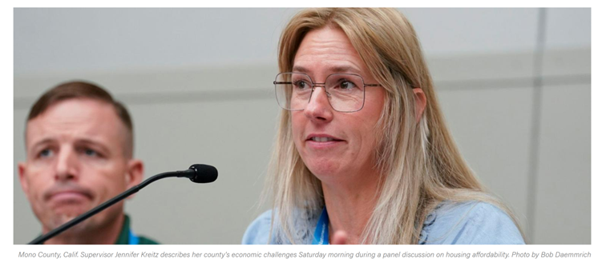
When it comes to housing affordability, no matter what size your county, it’s likely a problem with no easy answers. Creativity is vital to the solution.

Curbing the Crisis: County Recommendations to Advance Housing Affordability
July 22, 2023
NACo Annual Conference - Travis County, Texas
NACo President Denise Winfrey kicked off the meeting, observing that “people who should be out and on their own are still in the basement, in spare rooms, still on the couch … because they can’t afford to go anywhere.”
“Fresh out of school, they’re getting started, they don’t have the resources to afford anything decent to live in,” she noted. “I’m not talking about anything fancy, just a studio with a bathroom. It’s very expensive.”
Like other counties across the country, Winfrey noted that in her community of Will County, Ill., where she is on the county board, residents are seeing fewer and fewer housing options.
County officials explored answers to the housing affordability problem during a panel discussion Saturday moderated by Valley County, Idaho Commissioner Sherry Maupin, who co-chairs the NACo Housing Task Force. Even rural counties like hers, with a population of about 12,500, see housing challenges, she noted.
Maupin noted that all counties need to find “common goals and solutions for a growing problem and throughout our time on the Housing Task Force, that’s exactly what we’ve been working to achieve.”
In Mono County, California, we’re 94 percent public lands, said Mono County Supervisor Jennifer Kreitz, with some people living across the border in Nevada, where it’s cheaper to live.
“We have to look at ‘OK, what are the needs? And how do we start chipping away at it, little by little? That is sometimes the best way, is incremental changes. We just set aside $2 million of our ARPA funds for housing in Mono County, so we’re trying to get four units here, five units there.” The county has a population of 13,000. “That’s really how we’re going to bring back housing for everyone.”
When it comes to housing affordability, said panelist Williamson County, Texas Judge Bill Gravell, the size of your county doesn’t matter. “It doesn’t matter how small you are or how large you are,” said Gravell, whose county is located just north of Travis County with a population of more than 700,000.
“What matters is how creative you are,” he said.
“We work hard to fund our police force,” he said. “I’ll never forget the day I was riding with a deputy, and we were riding in a school zone. He said he and his wife loved the community but could not afford to live there.”
Gravell said later he asked himself “What’s wrong with us?”
The chief of police in Round Rock, Texas introduced Gravell to a police officer and his wife who had purchased 2.5 acres in a part of town that no one else wanted.
“They began to build a tiny home community of permanent houses, two-story homes, 880-square feet, your own driveway to park in. They built 28 units on the space. They were leased in 48 minutes. Only police officers, teachers, grad students and paramedics could live there.”
During a meeting with other members of the NACo Housing Task Force, he told other county officials about the community. “And Sherry [Maupin] said ‘Judge, that’s hero housing.”
Since then, Gravell said he brought builders and developers together. I’m proud to announce that we now have an association of home builders and developers in our area that have created a coalition called the Hero Housing Nonprofit. Their total capital investment is $65 million. By the end of next year, they’re putting 500 units on the ground.”
“As a county leader, do not think you cannot drive this train,” he said. “You don’t have to be a bully, you have to be a cheerleader.
You have to get with the community and say ‘Hey, those cops who are protecting your subdivision, don’t they deserve to live in your subdivision? Those teachers teaching at your elementary school, don’t they have the right to be able to live in that community?”
Other creative ways of tackling the problem including purchasing unused county property, was discussed by Commissioner Rene Flowers of Pinellas County, Fla., where the population stands at 968,000 and continues to grow.
Her county made an inventory of all county buildings and property to find out if they could sell them to make way for affordable housing.
“What property does the county own that is not being utilized? Let’s put that property back on the market.” In all, the county now has 11 properties in development after finding county property that was going unused.
Another factor that county officials need to consider, according to Washington County, Wis. Executive Josh Schoemann, is the growing number of Baby Boomers who are retiring.
“The challenge is, what the next generation looks like,” he said. “If your community is like my community, as Baby Boomers leave the workforce, you’re going to have huge gaps in knowledge, but more than that, think what it’s going to do to our non-profits, volunteer fire companies, all of the corporations and the communities themselves. Our county boardrooms will have the same problem.”
Schoemann said “if we can’t solve this problem right now, do the math.” He noted that a young family in their 30s, making a combined income of $100,000 in his county only has 20 homes to choose from that are under $300,000 in a county with a population of 140,000.
“There’s nowhere for them to live,” he said.

